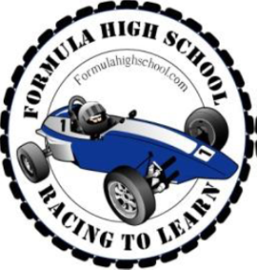
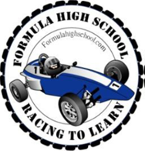
Team NAPA
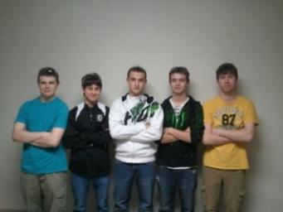

From left to right: Carson Cozzens, Matt Pasterski, Nick Stueber, Nick Treadway, Joe Van Egeren

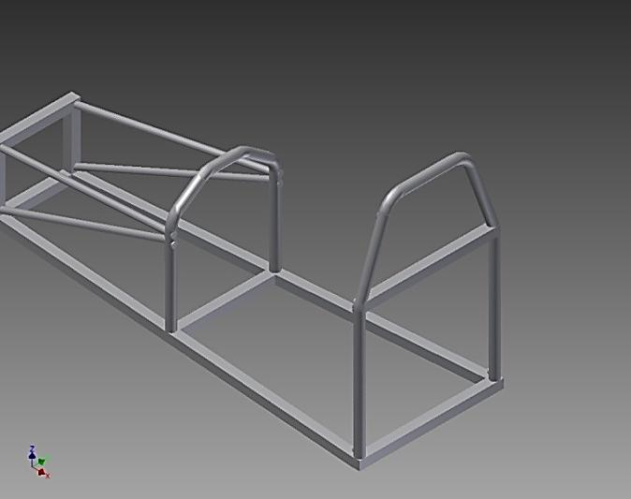

On our first few weeks of progress we successfully welded together the base chassis as shown to the left. We also took some time to practice welding on some scrap metal just so we would be ready to weld the rest correctly.

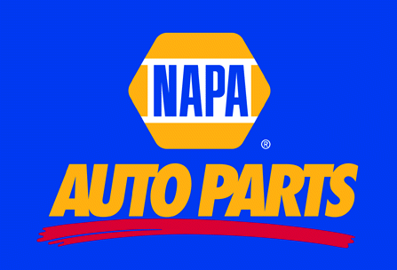

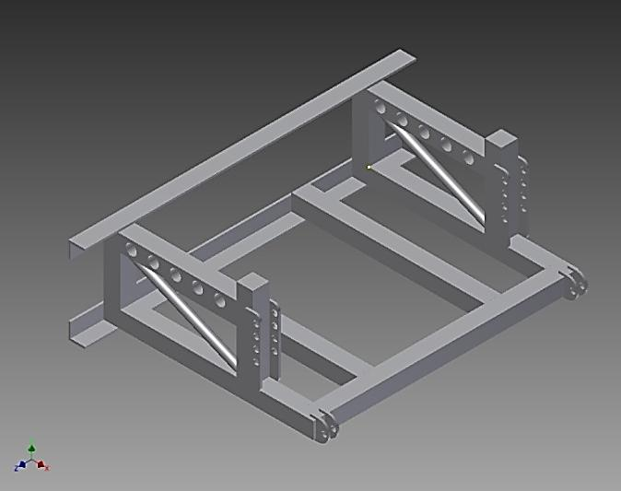
Our team designed the rear chassis as shown to the left. It was not yet built at this time but we came up with a good idea for a suspension system that would allow for a smoother and more efficient ride.

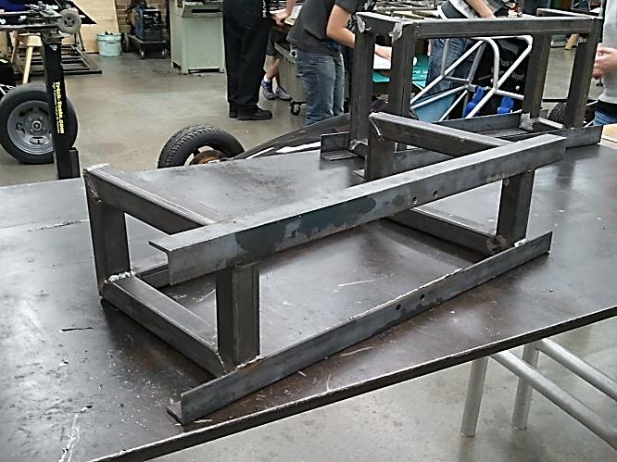
This is the start of the assembly of the rear chassis. We had to make sure it was completely square and level in order for this to work correctly.

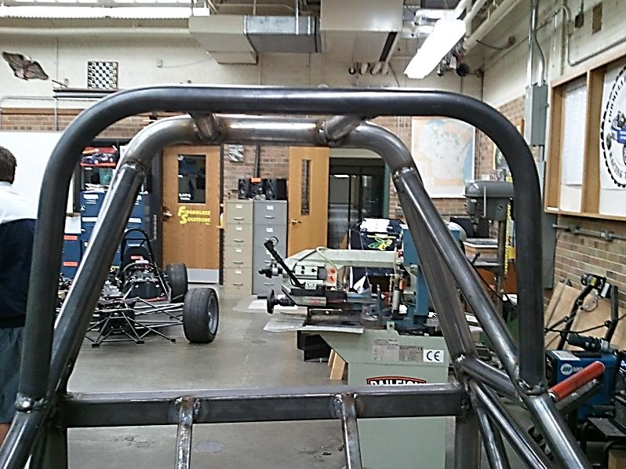
Later on, we started the assembly of the base chassis. We successfully bent the halo bar and welded it into place as seen in the picture to the left. After that we cut and welded in place the seat support bars to support the aluminum firewall.

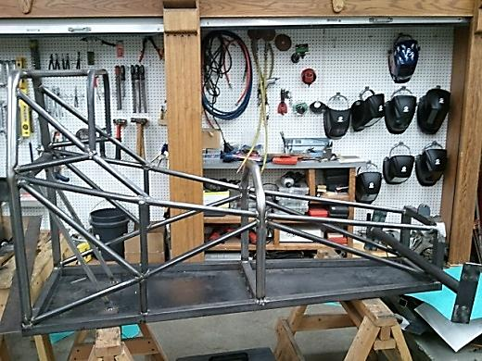
This is the completed base chassis along with the front axle. The axle at this point was not ready to be welded onto the chassis because we still needed to make a few slight adjustments to it first. Also we started to cut out the kill switch mounting plates and start welding them on.

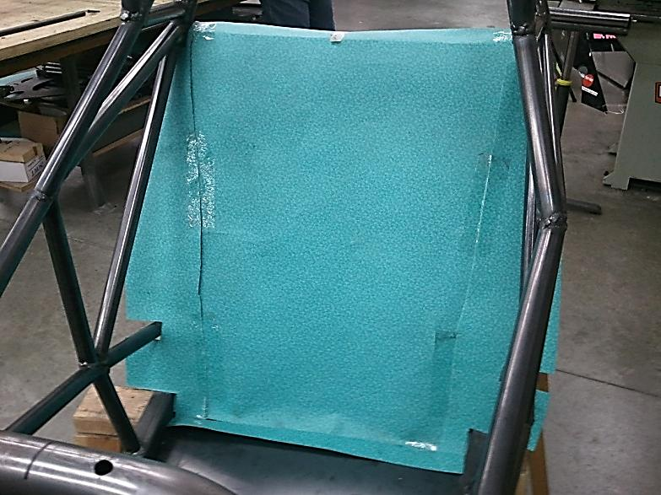
We then started to cut out the template for the aluminum firewall which would be needed in the future to make it easier to cut the aluminum to the perfect size. During this time we also cut the holes in the middle roll bar in order to bolt down the steering wheel.

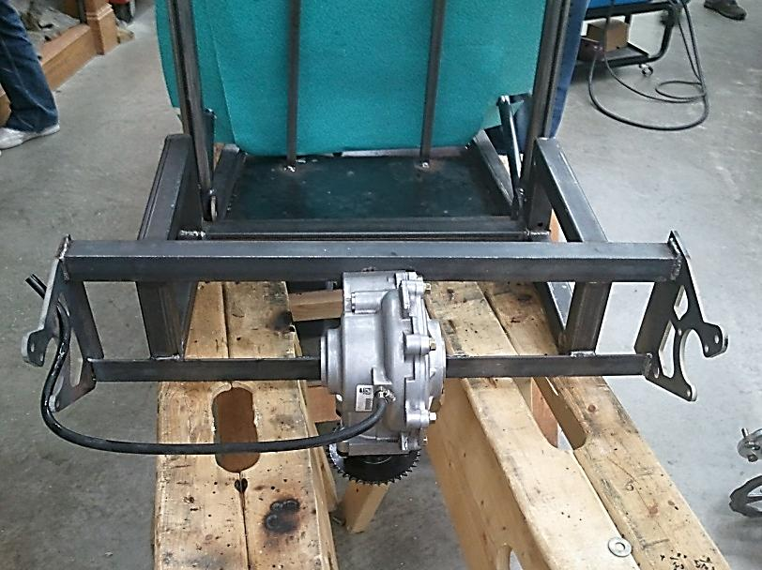
At this point we also finished the differential that was bolted onto the rear chassis and also the brackets on each side that would hold the rear axle in its place. At this point everything in the back had to be perfectly level so that the axle would not wobble at all.

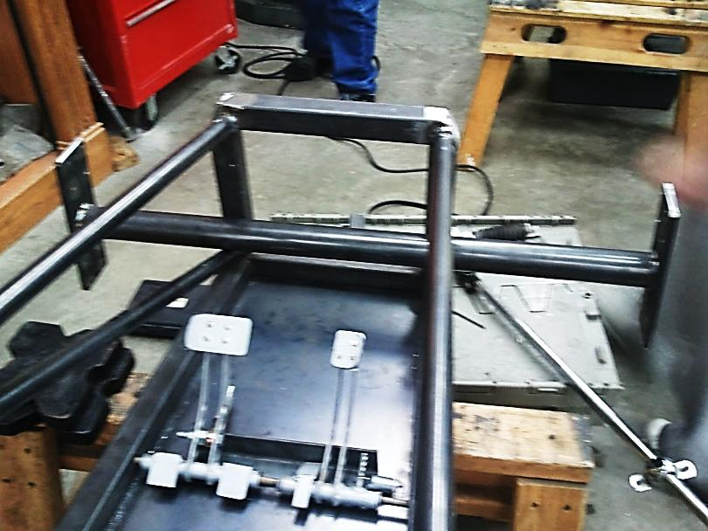
In the picture shown to the left you can see the pedals that were attached to the chassis. We made sure that everyone on the team could reach the pedals and still be comfortable on the seat at the same time. This picture also shows the front that had to be ground down in order to fit the nose cone over the chassis.

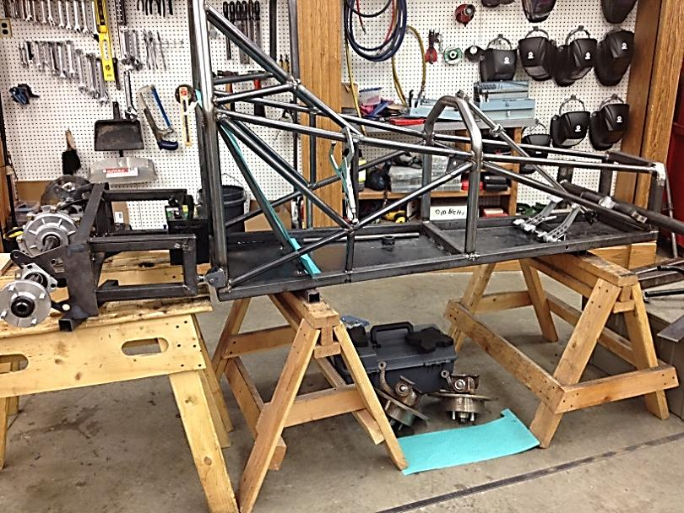
This is a picture of the full chassis put together along with the rear axle put into place just to see if it would work correctly. We also welded and drilled the brackets that would attach the rear chassis and allow for suspension.

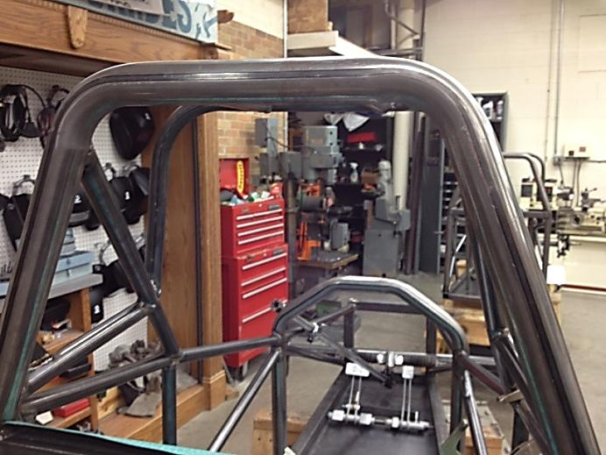
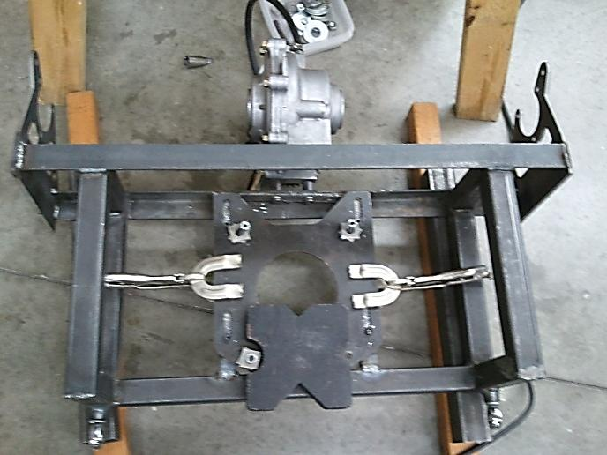
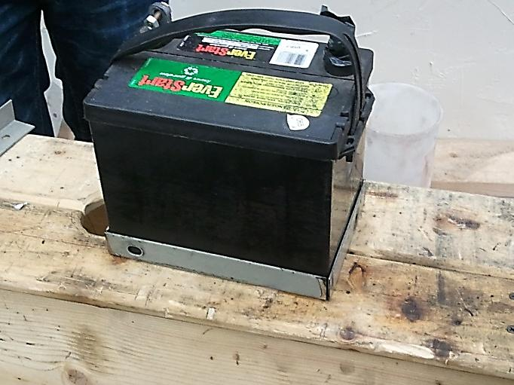
In this picture you can see the steering rod coming up from the front of the chassis. At this point we started finding a way to bolt it to the middle roll bar.

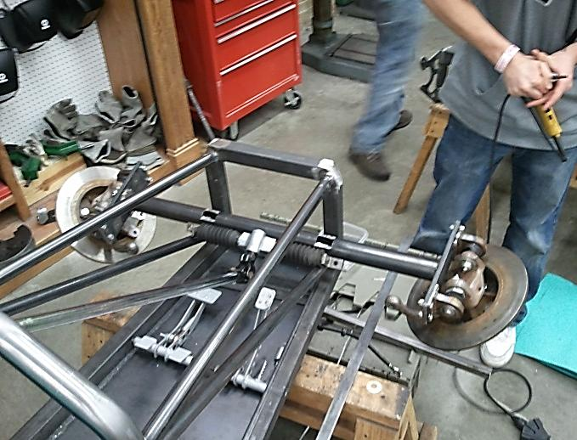
This is the front axle that is basically ready to be welded onto the car. We have mounting plates that were cut out on the plasma cutter and all we have to do is just weld it on. But before we do that we have to finish bolting on the disk brakes.
We had to design an efficient way to hold up the battery and mount it to the front of the car. So we simply just cut 4 pieces at 45 degree angles and welded them together as shown in the picture at the left. This worked very well and looks pretty nice too.
We then took off the rear axle on the rear chassis and started to take the engine plate off the engine. We cut two support bars that are welded underneath the plate. And we drilled holes through them in order to mount the engine.

Future Plans

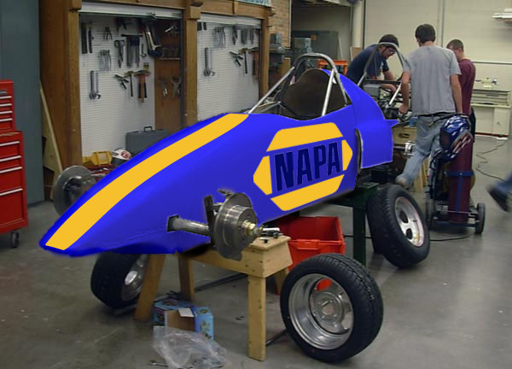
After successfully mounting the front axle, we will begin to mount the motor in the swing arm assembly. The swing arm still needs to have brackets welded to it to account for the spring shocks. After the motor is mounted, the rear axle will be set to install and we will begin mounting the tires and connecting the tie rods. The tie rods and the steering are ready to go, but we are still waiting on setting the front axle at the correct height. We have been working tediously to remove the decals and vinyl stickers from last year’s fiberglass body. We will be sending the body to NWTC to be painted in a metallic NAPA blue, and we will add a yellow stripe down the center in decal. Large NAPA stickers will be put on either side as well. After the body is painted, and the motor mounted, we will begin the wiring and brake calibration as well as installing the fuel tank and battery. The battery housing is almost complete and needs some work to fit correctly in the nosecone.
Artistic Interpretation

